Corona Virus Epidemic data Visualization

Name of the Student

Name of the University

Authors note

# Visualization 1

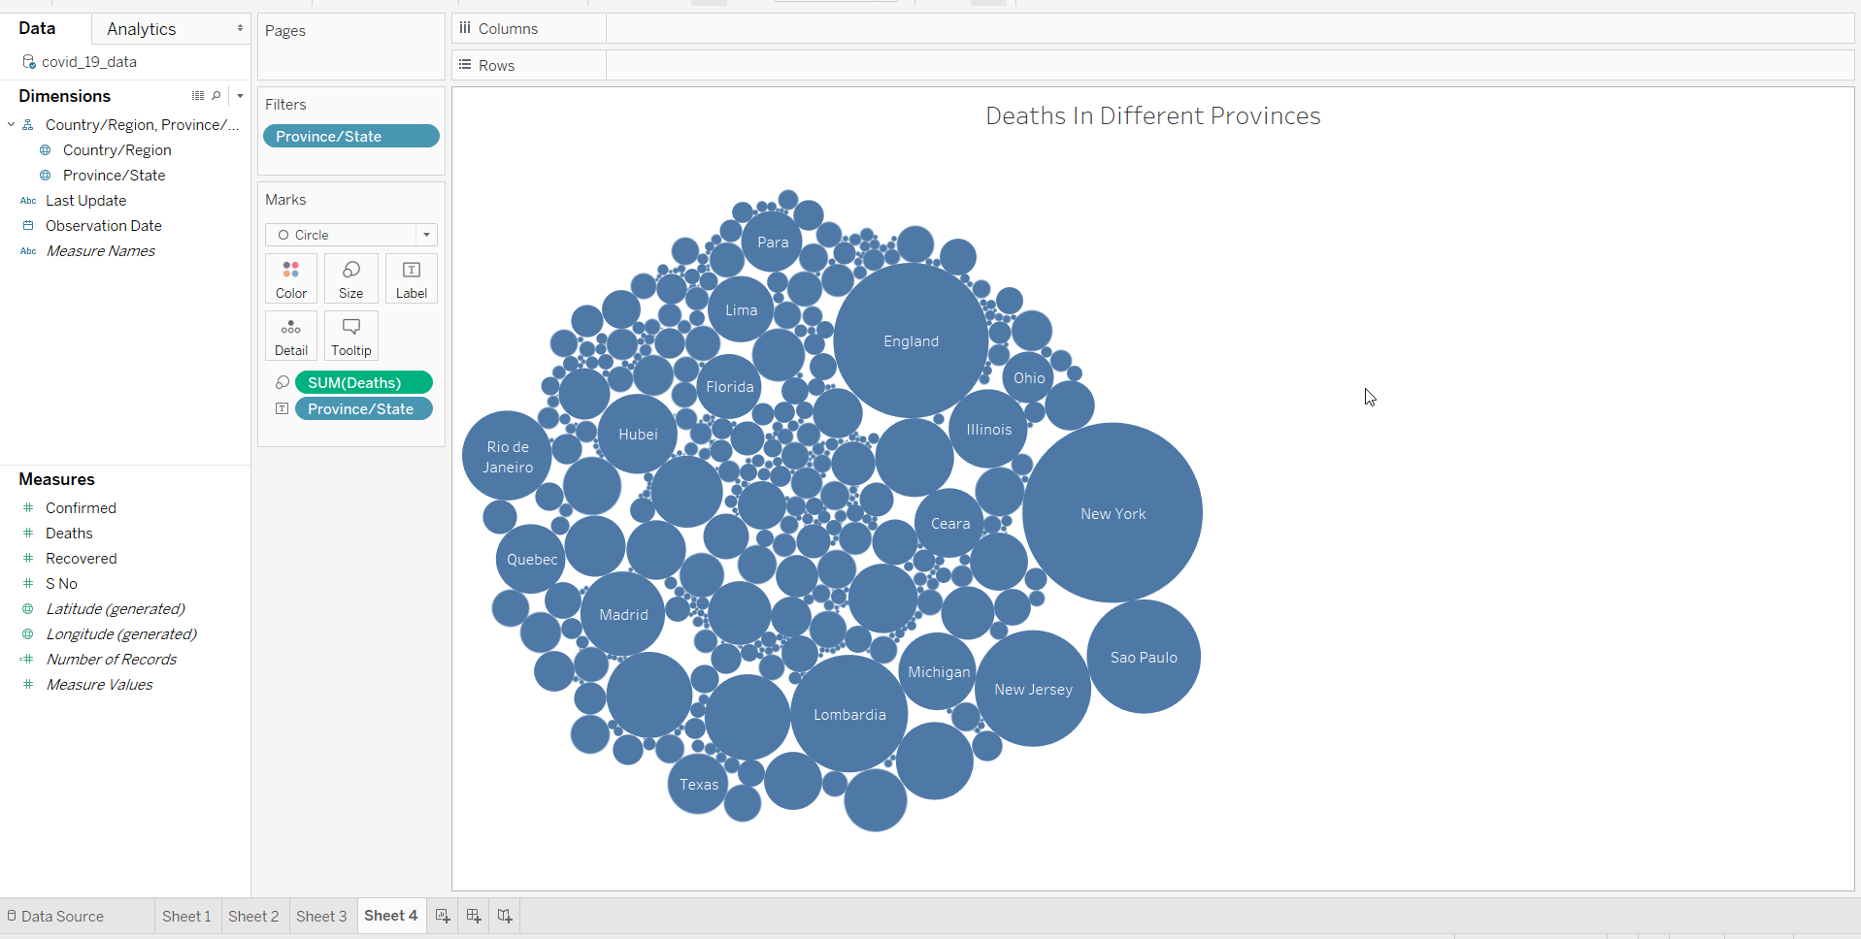

# Visualization 2

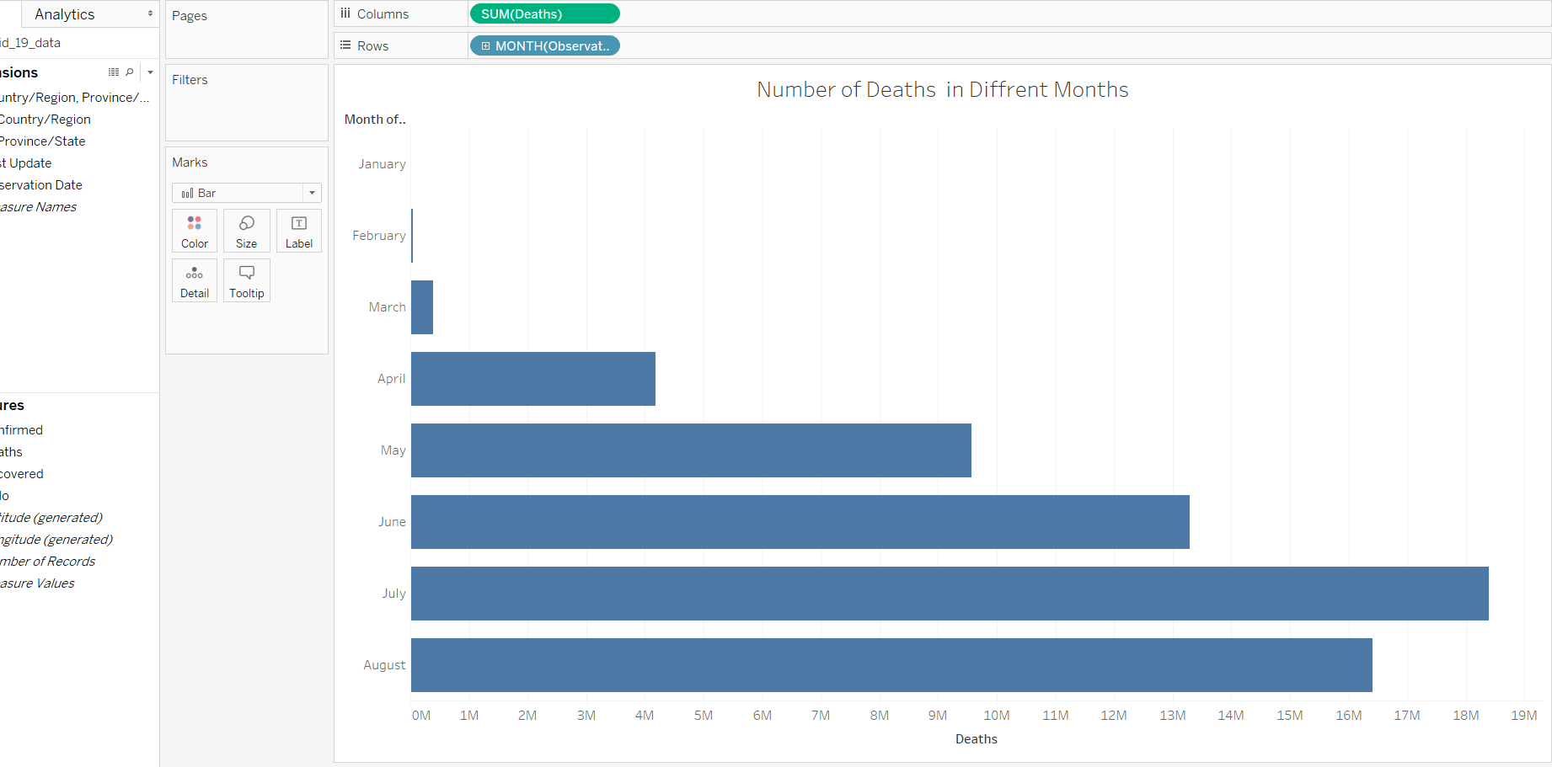

# Visualization 3

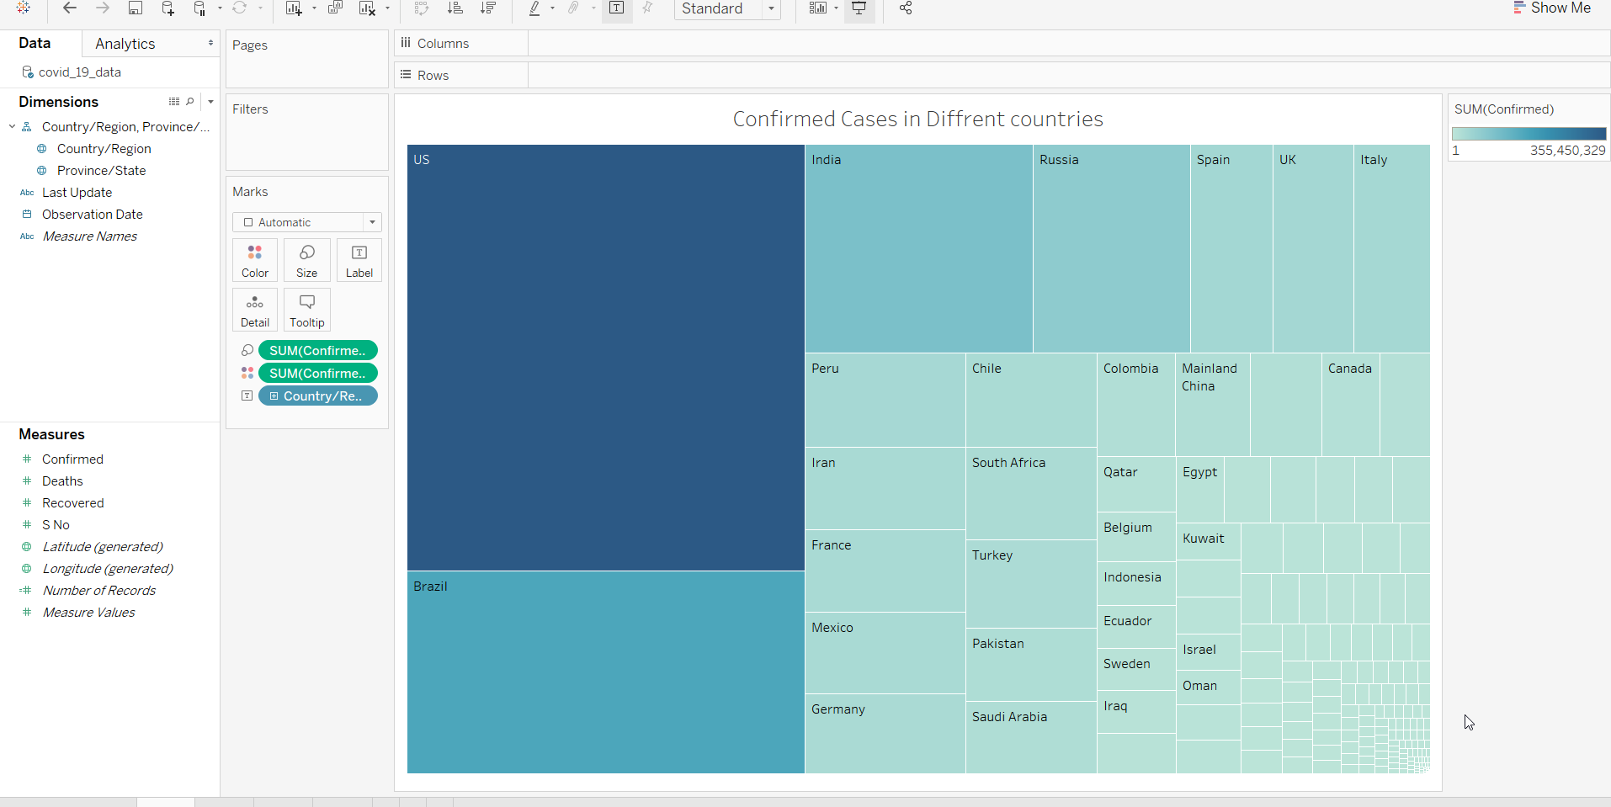

# Visualization 4

